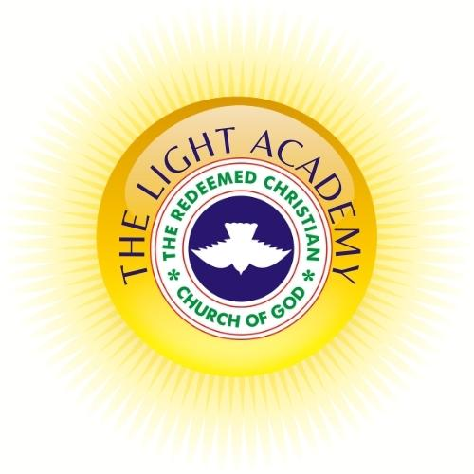
The Light Academy
(Ofsted Approved)
Education division of
The Redeemed Christian Church of God, Covenant of Grace
(Restoration of Hope through Christ)

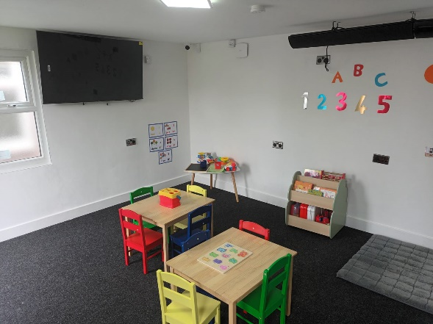

About us
Welcome to The Light Academy, a trading name for The Redeemed Christian Church of God, Covenant of Grace, with the head office at 25 Edgehill Road, Leicester, LE4 9EA. Having successfully organised diverse child development events, we have now taken the next step to transform this experience into a focused project. We are collaborating with professionals to provide children with the necessary support, ensuring they have an excellent start in their development through embracing play and learning opportunities.
Enrolling your child in the appropriate childcare services is of utmost importance, as it lays the foundation for optimal learning and life development. This decision is one that parents should consider carefully. Each child is distinct, and their learning should be individualised. Therefore, supportive key persons and a reassuring learning environment are crucial in nurturing and developing children into confident, self-assured future leaders.
At The Light Academy, TLA, our staff go beyond their call of duty to build a sustainable relationship with the children in their care and the parents/carers. Hence, we can support families by picking up children from home in the morning and returning them home in the evening. Our flexibility assures parents that their children are safe while under our case, and they have peace of mind to pursue and advance their careers while their children develop in our enabling environment.
We have integrated assembly time into our routine, where the children in our care sing and pray with the Pastoral team. We pride ourselves on being open all year round, except for Christmas and bank holidays, providing care for 52 weeks a year. To enrich our activities in line with the Early Years Foundation Stage (EYFS) curriculum, we incorporate various local trips to foster the development of the children.
As an inclusive and multicultural academy, we warmly welcome children from all cultures and backgrounds, valuing their unique intersectionality.
Our mission is to offer every child the best possible start in life, cultivating well-rounded and confident individuals who can achieve their full potential. We accomplish this by tailoring learning activities to meet each child's individual needs and providing appropriate resources in our play areas. Through the key person system, we assign an adult to your child to foster a positive relationship and work closely with parents/carers to understand the child's learning and developmental needs.

We strive to prepare your child for formal learning in school while also instilling crucial life skills such as independence, building positive relationships, self-confidence, self-esteem, resilience, problem-solving abilities, critical thinking, creativity, physical skills, and healthy eating habits. We aim to nurture children to become well-equipped for life's challenges and opportunities.
Our curriculum focuses on the seven learning areas as specified by the Early Years Foundation Stage (EYFS). These include:

The Prime Area
- Language and Communication
- Physical development
- Personal Social and Emotional Development
The specific Area
- Mathematics
- Literacy
- Expressive art and design
- Understanding of the world
We know that every child matters, so we ensure they work towards their personalised goals. Also, provide opportunities throughout the day where children can interact and learn. We also work with professionals such as SENCo, Speech and Language therapists and the Local authority to meet every child's need.

We welcome feedback and comments that help us reflect on what we do and how to improve. Also, our doors are always open for parents/carers to come and discuss their child's learning and any concerns they may have. We also operate parent's evenings termly, allowing parents/carers to meet with their child's key person to discuss how their child is doing in the setting and agree on the child's next learning steps.

At the Light Academy, we use an app called "Tapestry". All parents and guardians will receive regular updates on the child's learning and development. This is a real-time online application, and the parents/carers can also share the child's learning journey at home with us using images.

The most crucial step is the love and care given to your child by all the staff.

Our Rooms

Toddler (2-3)
Our 2-3 rooms are set up with children's safety in mind so they can access resources while ensuring their safety. Children learn through play by exploring and learning to make choices at this age. The resources and activities are carefully structured to enable children to follow their interest in learning.
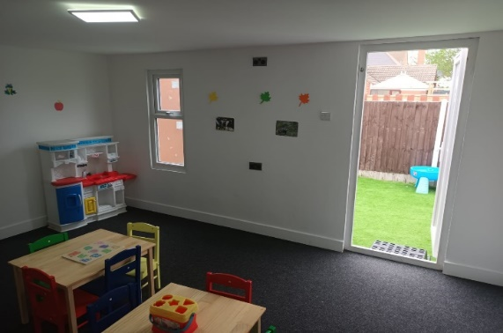

Preschool (3-5)
Our 3-5 room is structured to enable children to build on the skills they developed in the toddler room. At this age, children are geared towards more purposeful learning as they develop the ability to think for themselves and solve problems, collaborate with peers, gain more independence, and understand the world and how it works.

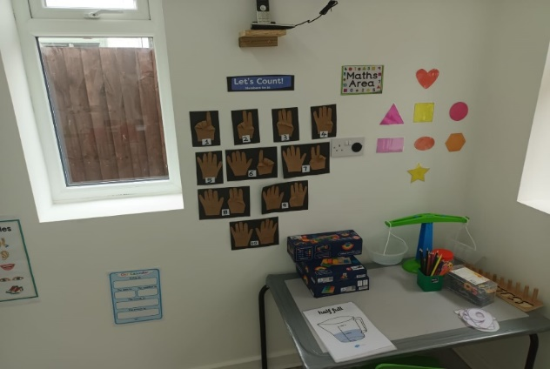
Outdoor Space 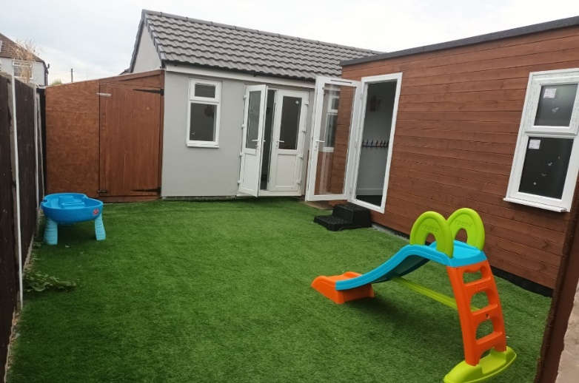
Our outdoor space supports the development of physical skills, develop self-confidence, resilience, independence, and self-esteem while learning. We also have access to local parks where children can explore their natural environment and have adventures.

Policies
Please speak to any member of staff for copies of our policies and application form or check our website www.tlaedu.uk for more details.

Contacts

25 Edgehill Road
Leicester
LE4 9EA
Phone: Key Workers: 0116 216 3000
Main Office: 0116 212 7759 or office@tlaedu.uk
Phone: Manager 0116 216 3000 of manager@tlaedu.uk
Website: https://www.tlaedu.uk

