|  |  |  |  |
| --- | --- | --- | --- |
|  | |  | |
|  | |  | |

The Light Academy

(Ofsted Approved)

**Education division of**

**The Redeemed Christian Church of God, Covenant of Grace**

**(Restoration of Hope through Christ)**

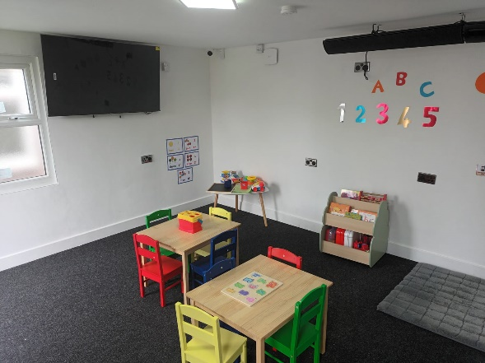

25 Edgehill Road

Leicester

LE4 9EA

Phone: Key Persons: 0116 216 3000

Main Office: 0116 212 7759 or [office@tlaedu.uk](mailto:office@tlaedu.uk?subject=office@tlaedu.uk)

Website: <https://www.tlaedu.uk>

**About us**

Welcome to The Light Academy, a trading name for The Redeemed Christian Church of God, Covenant of Grace, with the head office at 25 Edgehill Road, Leicester LE4 9EA. We have been successful in running various child development events and its time we made this a focused project to support and collaborate with professionals for preparing children for a very great start in their development through play and learning.

Enrolling a child in the right childcare is vital to giving your child the very best start in their learning and development in life, and this is a decision that parents do not take lightly. Every child is a unique and as a result, each child development is therefore specific and having key persons and setting that is reassuring cannot be overemphasised in building capable, confident, and self-assured future leaders.

At The Light Academy, TLA our key staff go beyond their call of duties to build a sustainable relationship with the children in their care and the parents/carers. Hence, we are able to support families by picking up children from home in the morning and returning them back home in the evening. Our flexibility gives parents the assurance that their children in our care are safe while they have peace of mind in becoming whatsoever, they would like to become in their career while their children are as well developing in our enabling environment.

At TLA, we have incorporated into our routine assembly time where children sing, pray with the Pastoral team and relate with one another.

At The Light Academy, we are open all year-round excluding Christmas and bank holidays. We are therefore open 52 weeks a year with various local trips incorporated into our activities aimed at developing the children in line with the Early Years Foundation Stage EYFS curriculum.

**Mission Statement:**

To give children the very best start in life so as to build well-rounded and confident children to enable them to achieve their full potentials in life.

**How to achieve this mission:**

We do this through providing children under our care with opportunity to learn through play in an enabling environment with the suitable resources.

Safeguarding is upheld at a very high standard. We have in place layers of security measure while this is monitored by the premises officer. However, we also have an experienced Designated Safeguarding Lead while all our staff are well trained to identify and raise safeguarding concerns.

We aim to deliver a high-quality childcare experiences and exciting learning opportunities that will prepare your child for school as well prepare them for life. The desire of every parent/guardian is to know that their child(ren) are in a safe environment and under the care of professionals. As a result, we aim to provide a home away from home experience for your child(ren) during their time with us. This we will do by working collaboratively with the parents and multidisciplinary stakeholders. We believe that every child is unique learn in their own unique way and this is what forms the bone of our practice. As a result, we provide individual learning experiences for every child by using the keyperson system whereby every child will have a consistent adult who will meet their individual needs. Also, our activities are tailored to meet the individual needs of our children using the child initiated and adult-led approach.

**Our curriculum**

We focus on the seven areas of learning.

*The Prime Area*

* Language and Communication
* Physical development
* Personal Social and Emotional Development

*The specific Area*

* Mathematics
* Literacy
* Expressive art and design
* Understanding of the world

As part of our holistic approach to the delivery of Early Years Foundation Stage (EYFS), our focus is also on quality care, education, safety, health, behaviour management and special educational needs.

The British values as underpinned by our faith are demonstrated through activities and all forms of learning. These include;

* Democracy.
* The rule of law.
* Individual liberty.
* Mutual respect.
* Tolerance of those of different faiths and beliefs

The Light Academy (TLA) is committed to meeting the requirements of the Statutory Framework for the Early Years Foundation Stage 2021. EYFS applies to all children from birth through to the end of their Early Years. More information about EYFS is available at the Department for Education’s website.

We recognise the four overarching principles of EYFS:

* **A Unique Child**: Every child is constantly learning and can be resilient, capable, confident and self-assured. We use positive encouragement and praise to motivate the children in our care.
* **Positive Relationships:** Children learn to be strong and independent through positive relationships. We aim to develop caring, respectful, professional relationships with the children and their families.
* **Enabling Environments**: Children learn and develop well in environments in which their experiences respond to their individual needs and where there is a strong partnership between practitioners and parents/carers. We observe children in order to understand their current interests and development before planning appropriate play-based activities for them.
* **Children develop and learn in different ways and at different rates.** The EYFS framework covers the education and care of all children in Early Years provision, including children with special educational needs and disabilities. We tailor the experiences we offer the children in our care according to their individual needs and abilities.

**Our Vision**

• Every Child Matters – Stay safe, Healthy, Enjoy/Achieve, Economic, Positive contribution. It is the central goal of Every Child Matters and we ensure that every child works towards their personalised goals.

• Interaction and learning – All children at TLA are encouraged to interact with one another while they all join the learning activities that are planned by our qualified staff around the EYFS and at age range. We also follow our children’s lead in learning by using the child-led approach. However, as children grow older and as their development allows, staff plan activities that are more adult initiated to help children prepare for more formal learning and school transition.

• Your child’s wants and needs – We collaboratively work with parents/carers to ensure needs of their children are met both in the setting and outside the setting

• Your expectations – We pride ourselves on meeting expectations where practicable in and around the nursery.

• Feedback – Here at TLA, we appreciate feedback and comments which help us to reflect on what we do and how to improve.

• Love and care – The most important step is the love and care given to your child by all the staff.

• To uphold policies and procedures – We endeavour to make our policies clear to all stakeholders while implementation is simplified.

**Rooms**

Below are the 2 rooms where your children will be learning. While we appreciate the need for substantial spaces for each of our children, we have put adequate measure in place to maximize the space that we have through limited number of children in each of the rooms, having staff on site to help arrange and ensure activities are carried out using age specific equipment.

***Age 2-3 Playroom***

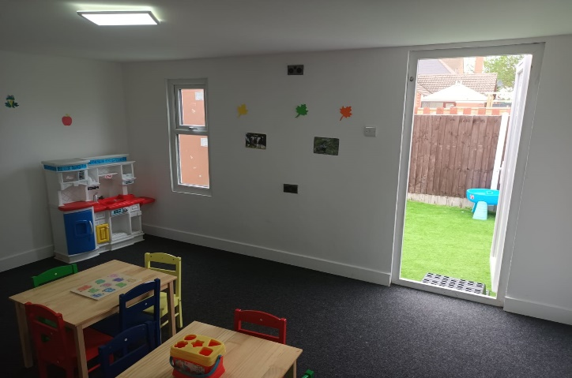

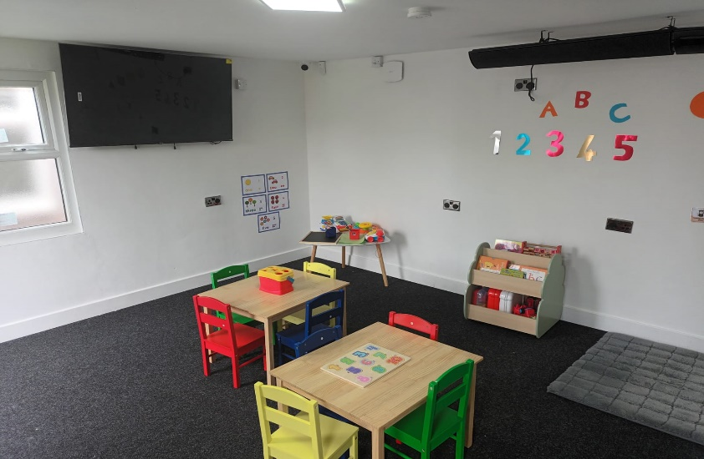***Age 3-5 Playroom***

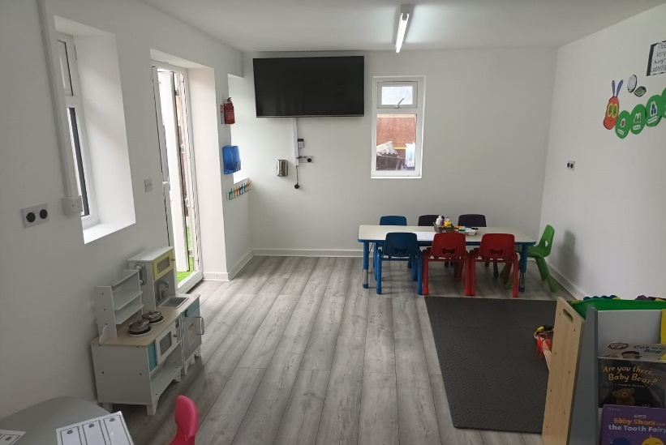

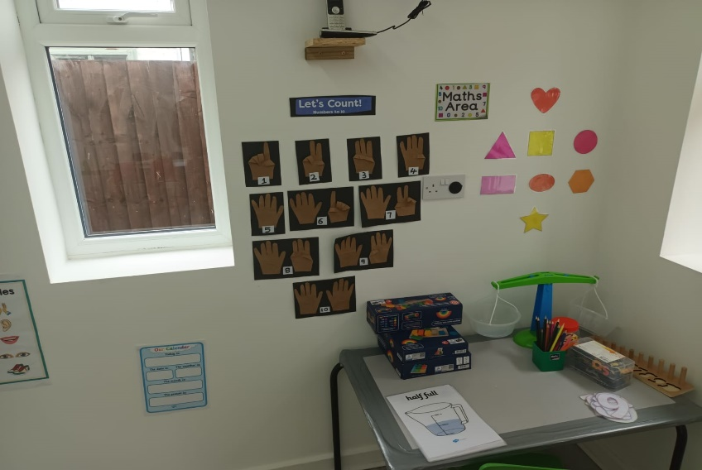

**Outdoor area**

Availability of indoor and outdoor play facilities are very crucial to promoting physical health development in Early Years Foundation Stage curriculum for children. This also support in the development of their physical skills while all other aspects of learning can also be best delivered in a multifaceted environment and seasons.

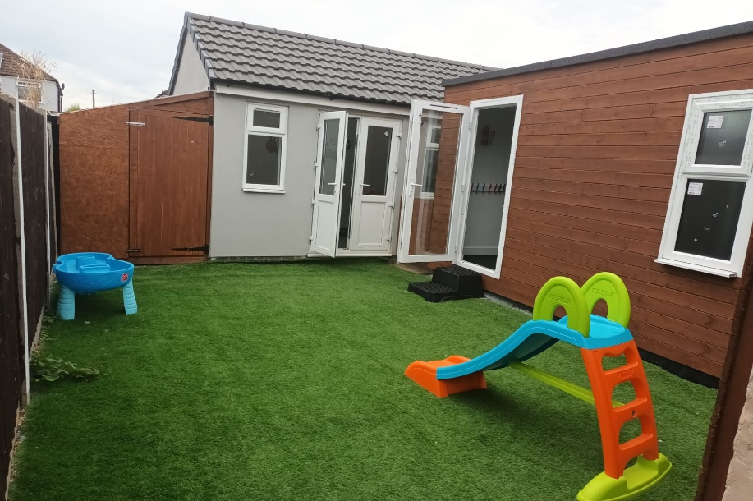

In addition to our outdoor area.

There are other local parks within a short distance from us where they can ride bikes, and engage in various sporting activities, library and many more.

**Parent partnership**

Communication

* At The Light Academy, we are committed to having a good working relationship with the parents and guardians as part of our holistic approach to child’s development. It also gives us the opportunity to ensure seamless transfer of information between the setting and the parents which is in the best interest of the child, which contributes to outstanding quality care within a stimulating environment.
* Parents will be kept up to date with any changes within the setting by means of regular verbal communication, phone call, newsletters, and information on the website.

At the Light Academy, we use app called “Tapestry”. All parents will receive regular updates on the child’s learning and development. This is a real time online application, and the parents/carers can also share the child’s learning journey at home with us at the setting with images.

**Parents Evenings**

This is to enable parents meet with the key person to discuss the development and the progress of their child. The entire management team and the key persons are always available during the parents’ evenings

**Safeguarding and Child Protection Policy**

We believe that every child has the right to a safe environment where children can be safe from harm as a result, we ensure that safeguarding children in our setting is every one responsibility. We are committed toproviding a safe environment for children, identifying children who are experiencing, or likely to experience significant harm, taking appropriate actions to see that such child(ren) is kept safe both in the setting and at home. We also work with other agencies to ensure that your child is safe.

**GDPR Data Protection policy**

At TLA, we collect data for record keeping purposes only. The information we collect is kept confidential and shared only on a need-to-know basis. This can be with professionals when required to meet the needs of children. Parents can also have assess to their child’s records on request. The data we collect are kept for the amount of time the law requires. These data include details of child(ren) and parents/carers. In times when we need to take photographs or videos, we will seek consent from parents/carers. They have the right to withdraw their consent at any time.